**Hello Team!** **Consider the below two tables**:

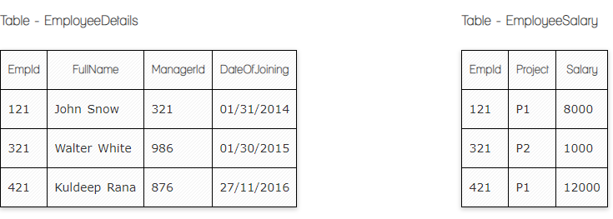

**Ques.1. Write a SQL query to fetch the count of employees working in project 'P1'.**

**Your Answer: Select Count(Empld), Project From EmployeeSalary**

**Group by Project having project=’P1’**

**Ques.2. Write a SQL query to fetch employee names having salary greater than or equal to 5000 and less than or equal 10000.**

**Your Answer: Select** **EmployeeDetail.FullName, EmployeeSalary.Salary**

**From EmployeeDetails Inner Join EmployeeSalary on EmployeeDetails.EmpId=EmployeeSalary.EmpId**

**Where EmployeeSalary.Salary between 5000 and 10000**

**Ques.3.** **Write a SQL query to fetch count of employees sorted by project's count in descending order.**

**Your Answer:** **Select count(EmpId) , Project from EmployeeSalary Group by Project order by count(EmpId) Desc**

**Ques.4. Write a query to fetch employee names and salary records. Return employee details even if the salary record is not present for the employee.**

**Your Answer: Select EmployeeDetail.FullName, EmployeeSalary.Salary from EmployeeDetail left Join EmployeeSalary on EmployeeDetails.EmpId=EmployeeSalary.EmpId**

**Ques.5. Write a SQL query to fetch all the Employees details from** **EmployeeDetails table who joined in Year 2016.**

**Your Answer: Select * from EmployeeDetails where DateOfJoining like ‘%2016’**

**Ques.6. Write a SQL query to insert new record to the** **EmployeeDetails table with any data.**

**Your Answer: insert into EmployeeDetails(FullName)**

**Values(‘Gohar Avetisyan’)**

**Ques.7. Write a SQL query to update EmployeeSalary table with setting Salary to 2000 for Project P2.**

**Your Answer: update EmployeeSalary set Salary=2000 where Project=’P2’**

**Now take these two tables:**

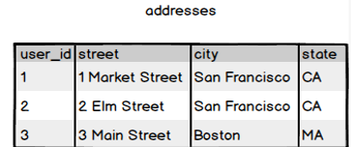

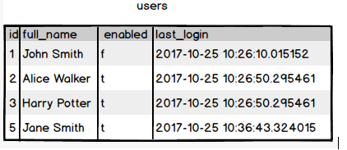

**Ques.8. Write a SQL query to fetch all users full_name from San Francisco.**

**Your Answer: Select users.full_name, addresses.city from users inner join addresses on users.id=addresses.user_id where addresses.city=’San Francisco’**

**Ques.9. Write a SQL query to fetch all users full_name, last_login who are enabled**

**Your Answer: Select full_name, last_login from users where enabled=’t’**

**Ques.10. Write a SQL query to fetch all users full_name who are not from Main street**

**Your Answer:**

**Select users.full_name, addresses.street from users inner join addresses on users.id= addresses.user_id where not addresses.street = ‘Main street’**

**Ques.11. Write a SQL query to fetch user full_name who is equal to user_id from Boston (find user_id value in sub_query)**

**Your Answer: Select full_name from users where id=(Select addresses.user_id from addresses where city=’Boston’)**